ALL TEAM CAPTAINS MUST CHECK-IN IF IN BOAT, ON THE WATER AT TWIN RIVERS (NO WAKE AREA) OR IF VESSEL IS TRAILERED, IN PERSON AT THE CIRCLE DRIVE AT THE FRONT DOOR OF THE PLANTATION INN BETWEEN 6:00 AND 7:00AM ON JUNE 15, 2024. CHANNEL 68 WILL BE MONITORED.

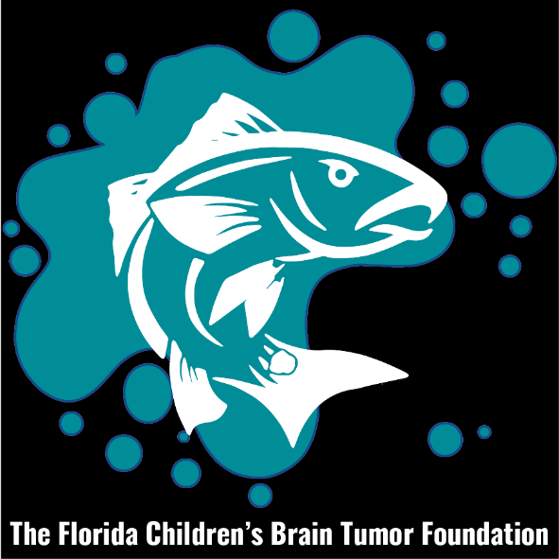

OFFICIAL ENTRY FORM
FLORIDA CHILDRENS BRAIN TUMOR FOUNTATION 12TH ANNUAL SALTWATER CLASSIC

$140 Entry Fee for Captain and Mate, plus $50.00 for each additional person. After 6-09-2024-$165.00

Name__________________________________ Mate___________________________
Address_________________________________ Add Person______________________
City/State/Zip____________________________ Add Person______________________
Phone #_________________________________ Add Person______________________
$Amount________________________________ Add Person______________________

Email Address____________________________

PAY ONLINE at www.childrensbraintumorfoundation.com or MAKE CHECKS PAYABLE TO F.C.B.T.F. If you pay online, please still complete this form and mail it to 740 SE 3rd St., Ocala Fl. 34471.

In signing this entry form I/WE waive and release all contestants, organizations, sponsors, host and tournament officials from any and all claims of injury, theft or damage from the fishing tournament. Please note that we will have camera crews filming this event, so any person involved in this event is subject to being filmed and used for publicity for this tournament.

SIGNATURE________________________________________________
Mail Entry to Trip Green, 740 SE 3rd St., Ocala Fl. 34471

