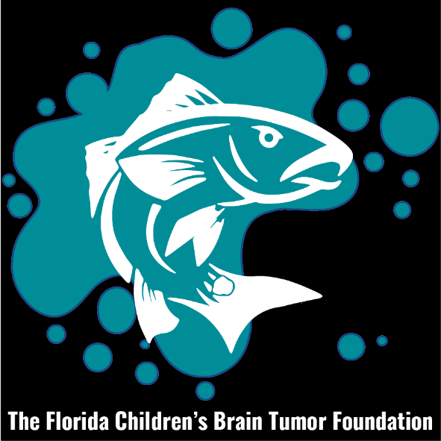
FLORIDA CHILDRENS BRAIN TUMOR FOUNDATION
12th ANNUAL “KIDS AGAINST CANCER” SALTWATER CLASSIC FISHING TOURNAMENT
SATURDAY, JUNE 15th, 2024
PLANTATION INN & GOLF RESORT, CRYSTAL RIVER, FLORIDA
RULES AND REGULATIONS

REDS (1 per person per day. Each boat can weigh 2 legal fish 18”-27” if two anglers fishing), BAG TROUT (5 trout 15”- 19” per boat with one over 19” included in bag limit), & BAG SNAPPER (4 Fish Aggregate. Each boat must have more than one angler. Bag can be comprised of Red Grouper 20”, Red Snapper 16”* or Mangrove Snapper 10” (*If in season)
ENTRY FEE (NO REFUNDS)
$140 Captain and Mate Postmarked or paid online by 6-09-2024. After 6-09-2024 - $165
$50 each additional participant. Applications will be accepted in person on June 14th, 2024 at registration between 5:00pm and 7:15pm at the Captains Meeting

This year’s tournament will be structured in a Calcutta format. Calcutta is $200 per boat

SCHEDULE
June 14, 2024-Cash Bar, Silent Auction and Raffle begin at 5:00pm at PLANTATION INN CONVENTION CENTER.
Captain’s meeting begins at 7:15pm at PLANTATION INN CONVENTION CENTER.

June 15, 2024 Tournament begins at 6:00am. Weigh-in begins at 2:00pm and ends at 4:00pm
Tournament Director reserves the right to reject any participant for any reason within his sole discretion.

ALL PARTICIPANTS MUST BE REGISTERED PRIOR TO CAPTAINS MEETING

GUIDES ARE NOT ALLOWED
SCORING
Determined by weight. Under or over-sized fish will disqualify team for that category. Weigh-in at the Gazebo, unless otherwise announced, 2:00pm to 4:00pm. First Place Fish, in each category, will be subject to being filleted. All fish must be caught on a hook and line.

Awards
Ceremony-June 16th, 2024 at 5:00 PM at the Plantation Inn Convention Center. Trophies and Prizes.

Tournament Director Sponsoring Hotel
Mail entries to Plantation Inn & Golf Resort
Trip Green 9301 W Fort Island Trail
740 SE 3rd St, Ocala Fl., 34471 Crystal River Fl. 34428
(352)-207-3925 1-800-632-6262-Mention Tournament

